Final Public Notice
Notification is hereby given to the public that the Montana Correctional Enterprises has requested funding from the Federal Emergency Management Agency (FEMA)’s High Hazard Potential Dam (HHPD) Program to rehabilitate Powell Dam. This notification is provided pursuant to the National Environmental Policy Act (NEPA), Executive Orders 11988 – Floodplain Management, Executive Order 11990 – Wetland Protection, Federal agency implementation procedures described in 44 C.F.R. Part 9 and FEMA Directive 108-1. Funding from FEMA’s High Hazard Potential Dam program will be utilized to implement cost-effective dam safety projects that result in safer and more resilient communities. This project would incorporate a sustainable design that would add improvements to the dam to increase the useful life of the structure and minimize risk in future events.
The President of the United States has issued Executive Orders that require Federal Agencies to focus attention on the environment, human health and safety when considering the funding of an action. Executive Orders 11988 – Floodplain Management and 11990 – Wetland Protection require federal agencies to avoid to the extent possible the long- and short-term adverse impacts associated with the occupancy and modification of floodplains/wetlands and to avoid direct and indirect support of floodplain/wetland development wherever there is a practicable alternative. With this public notice, FEMA is informing the public that the proposed rehabilitation of Powell Dam would occur in areas that are mapped outside the 500-year floodplain but will have both permanent and temporary impacts on the wetlands within the project area.
Powell Dam is located in Powell County, Montana on the Montana Correctional Enterprises Ranch, approximately 6 miles southwest of Deer Lodge, Montana. The dam is located in Section 16 of Township 7 North and Range 10 West at (46.354680, -112.850220). Powell Dam was first constructed in the 1960s and re-constructed in 1981 for irrigation and livestock purposes. Various modifications have been conducted to address seepage and slope failures along the toe of the dam.
The Montana Correctional Enterprise proposes to rehabilitate Powell Dam. The dam owner is planning to raise the crest elevation to provide sufficient freeboard to meet design requirements, widen dam crest to have a minimum width of 20 feet, flatten upstream and downstream embankment slopes, add riprap for wave action protection on upstream dam face, add a deep toe drain for seepage control and stability which includes a diaphragm filter around the low-level outlet, replace existing outlet pipe and valving with new pipe and new slide gate assembly, install new irrigation system controls and construct outlet stilling basin. Construction activities would be in accordance with all applicable federal, state and local laws, regulations and ordinances. There are no practicable alternatives outside the wetlands for this proposed project.
To minimize the 0.9 acres of permanent impacts and 1 acre of temporary impacts to wetlands, the dam owner will implement the following reclamation and restoration actions: salvaging and transplanting site wetland sod/plants and native soils, harvesting existing wetland sod/plants for replacement in the proposed toe drain location and other disturbance areas with suitable hydrology, salvaging topsoil material for later use in restoring disturbed areas, and making sure all wetland soils will be stripped and stockpiled separately. These soils will be used in the temporary impact area once construction is completed.
A public comment period for the proposed project described in this notice will remain open for 15 days from date of publication. If no substantive comments are received, the proposed project may proceed no sooner than 15 days after the comment period closes. Interested persons may obtain more detailed information about the proposed project by contacting by emailing fema-r8ehp@fema.dhs.gov or by mail sent to the Denver Federal Center, P.O. Box 25267, Denver, Colorado, 80225, subject line: Powell Dam Rehabilitation Project.
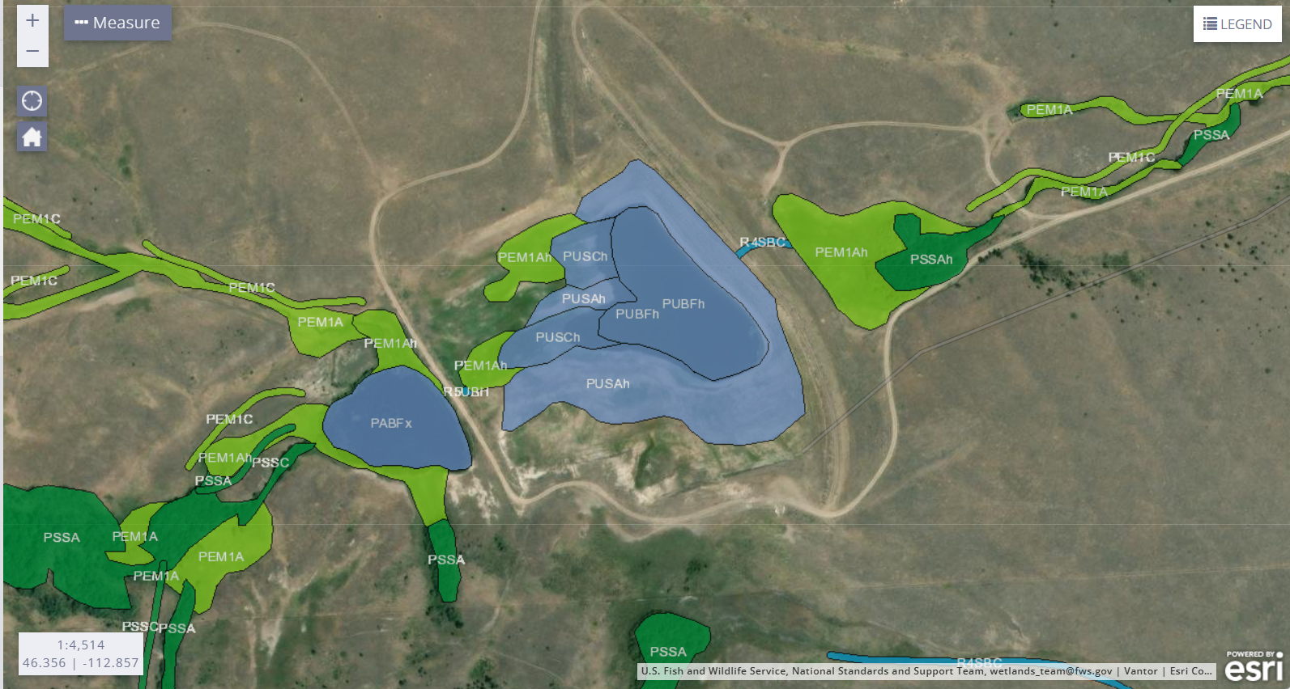
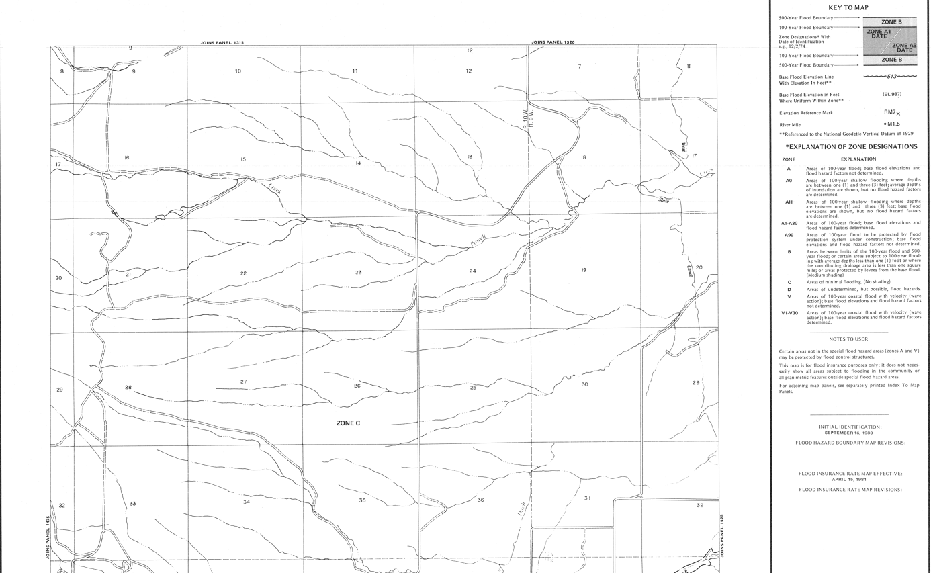
End of Notice

